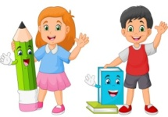
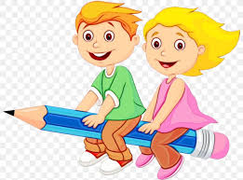
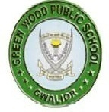
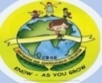
GREENWOOD PUBLIC SCHOOL, ADITYAPURAM
OUR MOTTO - DEVELOPMENT WITH DELIGHT
SYLLABUS FOR THE MONTH OF SEPTEMBER (2021-22)
CLASS-NURSERY
SUBJECTS
English | Oral: Rhymes – Moon , Two little Dickie Birds Roses are Red.  Written: J ,K, L ,M ,N, O, Fill in the missing alphabets , what comes after , write the first letter of the picture , match the same letter.  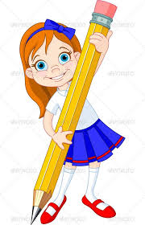  Recognition: A to Q  Workbook: Page No – 12 to 26
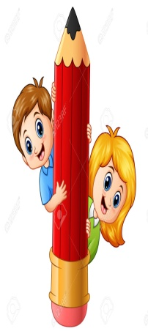  Hindi | Oral: कवितायेँ - अच्छे बच्चे , वर्षा , छोटू राजा !  Written: स्वर ए से औ तक , अक्षर का अक्षर से मिलान कीजिये , जोड़ी मिलाओ , खाली स्थान भरें , चित्र देखकर पहला अक्षर लिखिए !  Recognition: स्वर अ से औ  Workbook: Page No 14 to 30
Maths | Oral: Counting 1-20 , Table of 2  Written: 7 , 8, 9, 10 Table of 2, Match the same number , count the object and write the number , fill in the missing number , what comes after  Recognition: 1 to 10  Workbook: Page No 14 to 25
G.K. | Body Parts: Eyes , Nose , Ears , Hands , Legs , Mouth , Stomach , Neck , Head , Lip , Knee , Foot , Chin.  Pet Animals: Cat , Dog , Cow , Donkey , Horse  Wild Animals: Lion , Elephant , Tiger , Zebra , Giraffe
Drawing | Page no : 18-21
Conversation | English Conversation  Q.1 What is your name.  Ans- My name is ……….  Q.2 What is your father’s name?  Ans- My father’s name is--------.  Q.3 What is your mother’s name?  Ans- My mother’s name is--------.  Q.4 How many brothers, sisters do you have?  Ans-I have ___brothers ____sisters.  Q.4 When do we celebrate teachers day ?  Ans- 5th September | Hindi Conversation  प्र1: आपका नाम क्या है?  उत्तर- मेरा नाम_____  प्र2: आपके पिता का क्या नाम है?  उत्तर - मेरे पिता का नाम ______ है  प्र3 आपके माता का क्या नाम है?  उत्तर मेरे माता का नाम ____ है  प्र4 आप कितने भाई और बहन है?  उत्तर: हम ___ भाई और ___ बहन है  प्र4 शिक्षक दिवस कब मनाया जाता है?  उत्तर: शिक्षक दिवस 5 सितम्बर को मनाया जाता है !
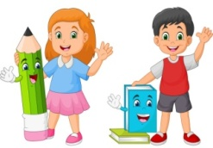
GREENWOOD PUBLIC SCHOOL, ADITYAPURAM
OUR MOTTO - DEVELOPMENT WITH DELIGHT
SYLLABUS FOR THE MONTH OF SEPTEMBER (2021-22)
CLASS-LKG
SUBJECTS
English | Rhymes Oral : Georgie Porgie , Little Poll Parrot , Good Manners  Reading : Alphabet sounds (revision of a-r)  Written : small cursive letters (s-z) write the first letter of the picture , match the following , what comes after  Book : (Jasmine) Activity 1-4 page no 20-23  Holiday HW: Page no 9-12
Hindi | Rhymes oral : कवितायेँ – जी भर मौज मनाएंगे , इंटरनेट बना बढ़िया , हम भी लड़ने जाएंगे  Reading : व्यंजन वर्ण क से ज्ञ तक  Written: व्यंजन वर्ण - प से ज्ञ तक और क से ज्ञ तक का पुनः अभ्यास , खाली स्थान भरे !  Book : अनमोल शब्द page no 9-12  Holiday HW : Page no 20-24
Maths | Rhymes Oral : Revision – Counting 1-100 , Table Of 2 And 3 , Number Names 1-10  Written : Table Of 3 , Counting 1-100 , Numbers Names 1-5 , Fill Ups , What Comes Before , After And Between.  Holiday HW :Page no 36-42
Drawing | Book (Draw And Create) Page No 21-25
G.K. | Dresses , Stationary , Body Parts

 | NATIONAL SYMBOLS  1.Our National flag is Tricolour.  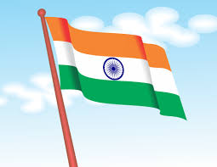  2.Our National Symbol is Ashoka’s Emblem.  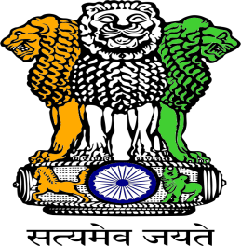  3.Our National sweet is Jalebi.  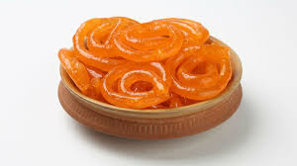  4.Our National bird is peacock.  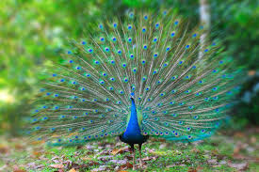 | 5.Our National animal is Tiger.  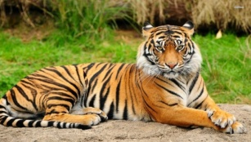  6.Our National flower is Lotus.  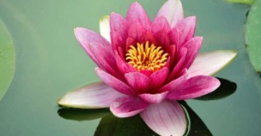  7.Our National game is Hockey.  8.Our National fruit is Mango.  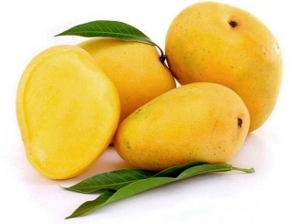  9.Our National tree is Banayan Tree.  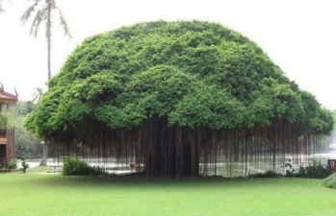

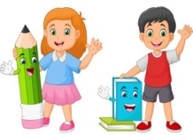
GREENWOOD PUBLIC SCHOOL, ADITYAPURAM
OUR MOTTO - DEVELOPMENT WITH DELIGHT
SYLLABUS FOR THE MONTH OF SEPTEMBER (2021-22)
CLASS-UKG
SUBJECTS
English | Oral: Rhymes –Colours , Anna Maria , Opposites (In × Out , Laugh × Cry , Even× Odd , Hot ×Cold , Light× Dark , Far ×Near , Give ×Take , Night ×Day  Written: Rhyming words , use of A / An , use of and , fill in the blanks with a , an or and , use of this/that  Reading: Book (English primer) page no 19-23
Hindi | Oral: कविताएँ - हँसकर बोलो , गर्मी आई , मेरा परिचय , राष्ट्रीय चिन्ह  Written: पाठ-11 (ई की मात्रा ) पाठ-12 ( उ की मात्रा ) पाठ-13 ( ऊ की मात्रा )  Reading: पुस्तक (स्वर वाटिका ) Page No (27-35)
Maths | Oral: Counting From 151-250 , Table Of 6 And 7 , Number Names 31-40  Written: Number Names 31-50 , Table Of 6 And 7 , Shapes , Put The Sign ( > , < , =) And Counting 151-250
EVS | Oral: Means Of Transport , Planets Name  Written: Chapter 5 And 6 (Means Of Transport , Our Earth ) Planets Name
Drawing | Page no (9-12)
G.K. | Oral: Under The Sea , Birds , Domestic Animals And Wild Animals.

 | NATIONAL SYMBOLS  1.Our National flag is Tricolour.  2.Our National Symbol is Ashoka’s Emblem.  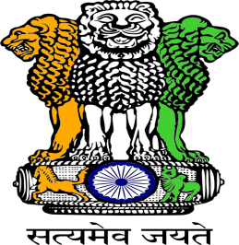  3.Our National sweet is Jalebi.  4.Our National bird is peacock. | 5.Our National animal is Tiger.  6.Our National flower is Lotus.  7.Our National game is Hockey.  8.Our National fruit is Mango.  9.Our National tree is Banayan Tree.

